Early Intervention and Preschool Procedure
The administration of first aid
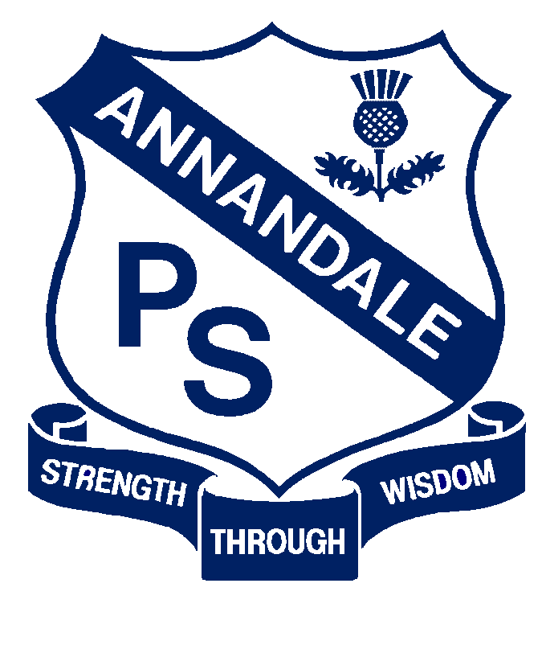

Current  Forbes Street Woolloomooloo 2013  T: 9358 5335/6  F: 93571831  E: plunketstr-p.school@det.nsw.edu.au | September, 2017
Next Review | 2018
Regulation(s) | R. 136, 89
National Quality Standard(s) | Standard 2.1: Health-  Each child’s health and physical activity are supported and promoted.
Relevant DoE Policy and link | Student Health in NSW Public Schools: A summary and consolidation of policy  First aid procedures
DoE Preschool Handbook January 2016 | Wellbeing, page 27  Staffing, page 59
Key Resources | ACECQA First aid qualification information and checker

- A full first aid kit is in the preparation room

- All preschool educators and casuals will hold the current mandatory DoE CPR, ASCIA Anaphylaxis e-training and face to face training, Asthma care and e-Emergency care certificates.

- In addition, one preschool SLSO has undertaken the ACECQA approved first aid, anaphylaxis, and emergency asthma training and is our nominated first aider. In her absence, and if the other educators require it, they will call on the Senior Administration Manager to assume this role.

- The nominated first aider also ensures the first aid kit contents are restocked and no items are out of date.

- A full first aid kit is in the preparation room. A portable first aid kit is kept on a shelf on the veranda, outside the Blue room for when the groups are outside. A separate first aid kit is assembled for excursions.

- Signage is in place to indicate the location of first aid kits.

- The Early Intervention class has a full first aid kit in their locker room.

