Early Intervention and Preschool Procedure
Dealing with medical conditions
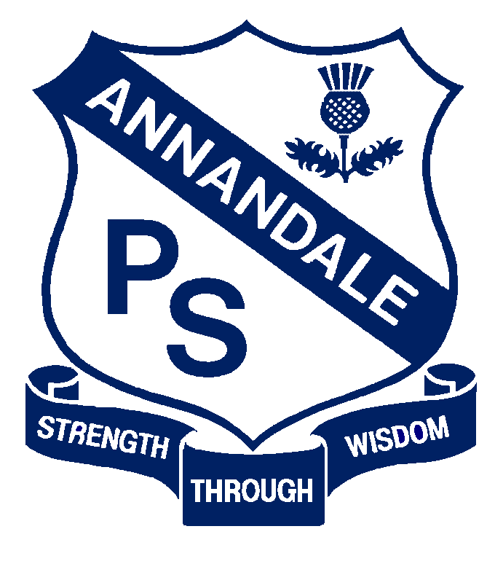

Forbes Street Woolloomooloo 2013
T: 9358 5335/6
F: 93571831
E: plunketstr-p.school@det.nsw.edu.au

Current | September, 2017
Next Review | 2018
Regulation(s) | R.90-91 R.136
National Quality Standard(s) | Standard 2.1: Health-  Each child’s health and physical activity are supported and promoted.
Relevant DoE Policy and link | Student Health in NSW Public Schools: A summary and consolidation of policy  Anaphylaxis Procedures  Administration of medication: Legal Issues Bulletin No.46 Jan 2012
DoE Preschool Handbook January 2016 | Wellbeing, pages 29, 31, 36
Key Resources | Administering prescribed medication at school  Asthma care plan for education and care services  Managing exposure to allergens in the workplace- sample risk management plan  Individual health care planning

Common Procedures:
- Educators will work with parents to support their children’s health care needs while they are at preschool. This may involve giving medication, performing health care procedures or developing an individual health care plan.

- The teacher will consult with the family to develop an Individual Health Care Plan for any child who is diagnosed with severe asthma, type 1 diabetes, epilepsy or anaphylaxis, is at risk of an emergency reaction or requires health care procedures. Parents and caregivers will receive a copy of their child’s health care plan once completed.
Further information about developing individual health care plans is available at:
www.schools.nsw.edu.au/studentsupport/studenthealth/individualstud/devimpindhc plan/index.php
- As part of this process, the teacher will consult with the family to develop an individual risk management plan for the child. This will be discussed with the family and their input sought. The teacher will then be responsible for implementing the preventative action listed on the plan.

- Furthermore, as part of the Individual Health Care Plan, the teacher will develop a communications plan. This will ensure all relevant staff members and volunteers are informed about the medical conditions procedure and the medical management plan and risk minimisation plan for the child, as well as setting out how a parent can communicate any changes to the medical management plan and risk minimisation plan for the child.

Preschool specific procedures:
- Families are requested to indicate on their child’s enrolment form on pages ten and eleven if their child has a medical condition or allergy. If so, after receiving the completed form, and before the child commences, the teacher will discuss the child’s particular needs at a pre-commencement interview.

- If a child with a known food allergy or anaphylaxis enrols in the preschool, all preschool families will be notified by way of a written notice, requesting they not pack the particular food or allergen in their own child’s lunch.

- If a child enrolled at the preschool has a specific health care need, allergy or other medical condition parents will be provided with a copy of the Department’s student health policy.

- When a preschool child with an individual health care plan transitions to Kindergarten, the preschool teacher will give their parents a copy of the current plan and encourage them to discuss it with the school at enrolment.

Anaphylaxis
- Anaphylaxis is a severe life-threatening allergic reaction and needs to be regarded as a medical emergency.

- All preschool educators will be made aware of children with allergies and consider ways to reduce their exposure to known allergens.

- When anaphylaxis occurs an emergency response is required.

- The Department of Education requires all staff to undertake Anaphylaxis training. Both the online and face-to-face courses are approved by ACECQA.

- Regulation 136 of the Education and Care Services National Regulations state that at least one person who has undertaken approved anaphylaxis training and one who has undertaken approved emergency asthma training must be in attendance and immediately available at all times.
Asthma
- whenever a child with asthma is enrolled at our service, or newly diagnosed as having a asthma, communication strategies will be developed to inform all relevant educators of:

- where the child’s Medical Management Plan will be located
-where the child’s preventer/reliever medication etc. will be stored

- Asthma reliever medications will be stored out of reach of children, in an easily accessible central location.

- Reliever medications together with a spacer will be included in our service’s First Aid kit in case of an emergency situation where a child does not have their own reliever medication with them.

Diabetes

- Educators will be aware of the signs and symptoms of low blood sugar including the child presenting pale, hungry, sweating, weak, confused and/or aggressive. Signs and symptoms of high blood sugar include thirst, need to urinate, hot dry skin, smell of acetone on breath

- Management of diabetes in children at our service will be supported by the child having in place an Emergency Action Plan

- Whenever a child with diabetes is enrolled at our service, or is newly diagnosed as having diabetes, a communications plan will be developed to inform all relevant educators of:
-the child’s Risk Minimisation Plan;
-where the child’s Emergency Action Plan will be located;
-where the child’s insulin/snack box etc. will be stored;
-which educators will be responsible for administering treatment.

Nappy changing and other toileting procedures
- If a child who wears nappies enrols in the preschool, a nappy changing area will be organised with a sink nearby. This will be separate from craft and food preparation areas.

- If a child enrols with a medical condition that require specific support for toileting, for example catheterisation, will need an individual health care plan. For additional information about plans see; www.schools.nsw.edu.au/studentsupport/studenthealth/individualstud/devimpindhcplan/index.php.

- Learning and Engagement officers in local Educational Services team will be contact for support, if required.

Medication
- All school staff must follow the Department’s Student Health in NSW Public Schools policy for administering medication to children. The policy states that the school (including the preschool) must assist with administering prescribed medication during school hours, if parents or other carers cannot reasonably do so.

- In general, our preschool will not give medication which has not been specifically requested by a medical practitioner for an individual child for a specific condition.

- In some cases the medical practitioner may prescribe an over-the-counter medication. If so, our educators will follow the same procedures as for ‘prescribed medications’.

The following procedures apply to giving medication:
- On arrival, parents give the child’s medication to an educator for safe storage.

- All non-emergency medication will be stored in a locked cupboard or locked container in the refrigerator, out of reach of children.

- Medication must be in its original packaging with a pharmacy label which states the child’s name, dosage instructions and current use-by date.

- Medication without this labelling will not be given.

- When an educator administers medication to a child, he/she will record this information and another staff member will verify that the medication was administered as prescribed.

- The record will include the name of the medication, the date, time and dosage given and the names and signatures of staff members who gave and checked the medication. This will be made available to parents for verification

- Permission forms to give medication for a prolonged period will be reviewed and updated when there is a change to the medication dosage or frequency. Administration of prescribed medication can form part of an individual health care plan

- Parents will be encouraged to advise if a child is on medication, even when it is not given at the preschool

- All medication forms will be kept in the school until the child reaches the age of 25 years

- There may be times when emergency medication needs to be given to children in the preschool. This will be documented in the individual health care plan (particularly for conditions such as anaphylaxis)

- If an emergency occurs, that has not been documented in the emergency response section of the individual Health Care Plan, preschool staff will provide a general emergency response, which may involve calling an ambulance.

