Early Intervention and Preschool Procedure
Emergency and Evacuation

Forbes Street Woolloomooloo 2013
T: 9358 5335/6
F: 93571831
E: plunketstr-p.school@det.nsw.edu.au

Current | September, 2017
Next Review | 2018
Regulation(s) | R.97-98
National Quality Standard(s) | Standard 2.2: Safety-  Each child is protected.
Relevant DoE Policy and link | Emergency Management Procedures – Health and Safety Directorate - intranet  Emergency Management
Relevant School Procedure | Emergency Management Plan  U:\5.2 Emergency_Management_Plan 2016.rtf
DoE Preschool Handbook January 2016 | Wellbeing, page 42
Key Resources

Common Procedures:
- Educators will need to act promptly in an emergency.

- The following information, with contact telephone numbers, will be clearly displayed next to each preschool telephone at all times:

Emergency number – 000
Poisons Information Centre (24hours)- 13 11 26
Local hospital casualty department- Royal Prince Alfred (RPA) 95156111
Local police – Glebe Police Station 95528099
Street address- 25 Johnston Street Annandale
Preschool telephone – 95163711
School office telephone- 95163711
Nearest crossroad to the preschool premises- Albion St

- The school emergency management plan to follow in case of ﬁre, ﬂood, bomb threat or any other emergency situation that requires evacuation of the building will include procedures for the preschool.

- All preschool staff, including relief staff, will be made aware of the emergency evacuation procedures. Copies of the procedures will be displayed in a prominent position at each preschool exit.

- All educators and children in the preschool will practice emergency evacuation procedures once a term. Considering the enrolment patterns of the group, the reality of this is that evacuation procedures will need to occur twice a term (once at the beginning of the week and once at the end), to ensure each group has participated.

- Details of each practice, including an evaluation of the procedures followed, will be recorded in a booklet in the preschool, as well the Department’s In Case of Emergency (ICE) electronic system and kept for two years afterwards.

- The preschool will develop (and review annually) a risk minimisation plan for emergency evacuations.

- Beryl to bring emergency bag which contains the roles of all rooms and staff, gate
key and individual emergency medications. In her absence, Karen will carry this out
or Meli.

- To raise the alarm in a real situation an alarm is released from the office.

- If a fire breaks out in the Preschool/EI area a staff member will call the office to
raise the alarm and notify other staff members immediately.

Early Intervention specific procedures:
- Noise reducing headgear is available for children who require them.

- In the case of an emergency the Principal will assist in the EI evacuation.

- Educators and children will exit the building using a safety web.

- All families will be notified by the teachers.

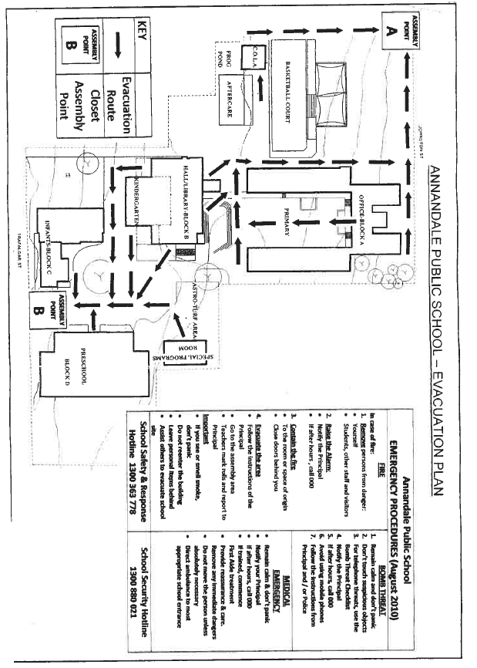

U:\5.2 Emergency_Management_Plan 2016.rtf

