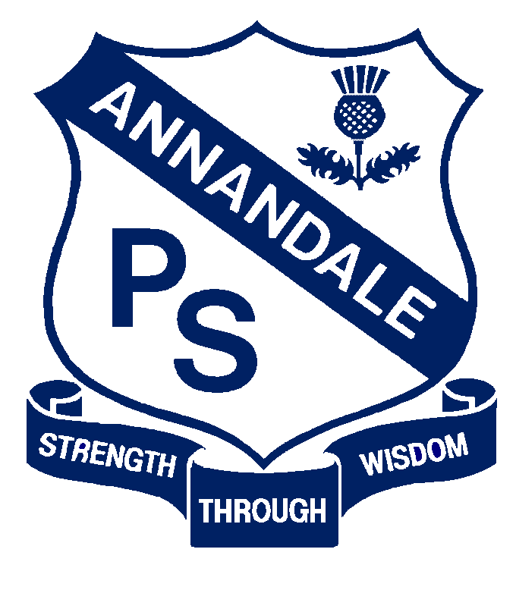
Early Intervention and Preschool Procedure
Nutrition, Food and Beverages, Dietary Requirements

Current | September, 2017
Next Review | 2018
Regulation(s) | R.77-78
National Quality Standard(s) | Standard 2.1: Health-  Each child’s health and physical activity are supported and promoted.
Relevant DoE Policy and link | Nutrition in Schools Policy PD/2011/0420/V01
DoE Preschool Handbook January 2016 | Wellbeing, p.34
Key Resources | Anaphylaxis Procedures for Schools  Food Safety Fact Sheet- National Childcare Accreditation Council Inc.  Healthy Kids Fact Sheets  Munch and Move. Healthy Kids: eat well, get active  Get up and grow: Healthy eating and physical activity for early childhood resources. Australian Government Department of Health  Promoting healthy eating and nutrition in education and care services – Early childhood resource hub  Department of Primary Industries NSW Food Authority  Staying Healthy in Childcare
Forbes Street Woolloomooloo 2013
T: 9358 5335/6
F: 93571831
E: plunketstr-p.school@det.nsw.edu.au

Common Procedures:
Allergies
- When a child with a known food allergy enrols, the preschool teacher will consult with the child’s family and principal to develop a risk management plan to avoid exposure to known allergens.
- A list of children and their reactive foods will be updated regularly and displayed with health care plans so that it can be seen by all adults involved in the program. This is especially important when children with anaphylaxis are attending the preschool.

- Parents of children with allergies will be asked to supply a substitute food to be frozen and given on special occasions such as birthdays.

- In term 4 when the preschool is involved in a cooking program in the whole school kitchen, the teachers will liaise with the program supervisor regarding particular allergies.
Health and Nutrition

- All preschool children will be exposed to healthy eating practices.

- The preschool program will promote good nutrition and help children and parents to develop good food habits. In addition, staff and children will discuss the relationship between nutrition, physical fitness and good health.

- Preschool educators will provide a positive and healthy eating environment. They will act as role models, maintain good personal nutrition and encourage independence and social skills at meal times.

- The preschool will provide nutritional information to parents. This may be through posters, displays, library information, newsletters and correspondence. This can help encourage parents to send food to preschool that is nutritionally balanced.

- Children will provide their own bottle of drinking water which will be available to them at all times.

Special events and birthdays
- Families are welcome to supply a birthday cake, or preferably cupcakes, to celebrate their child’s birthday.

- The teachers will communicate with families prior to any special events where food is involved.

Food preparation and handling

- Any area where food is prepared or stored will be kept clean and good hygiene and safety practices reinforced throughout all cooking activities.

- To reduce the risk of exposure to food allergens, staff in the preschools will follow the advice in Anaphylaxis Procedures for Schools.

Early Intervention specific procedures:
- Staff will supervise and support 1:1 in all food serving and eating/drinking experiences
- Food may be used as motivation for specific children on rare occasions and as part of the individual’s program

