Early Intervention and Preschool Procedure
Sun Protection
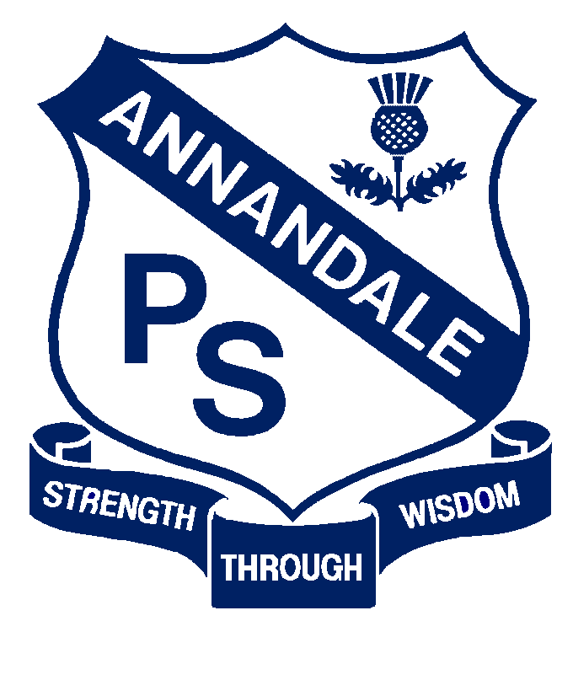

Forbes Street Woolloomooloo 2013
T: 9358 5335/6
F: 93571831
E: plunketstr-p.school@det.nsw.edu.au

Current | September, 2017
Next Review | 2018
Regulation(s) | R.114
National Quality Standard(s) | Standard 2.2: Safety-  Each child is protected.
Relevant DoE Policy and link | Student Health in NSW Public Schools: A summary and consolidation of policy
DoE Preschool Handbook January 2016 | Wellbeing, page 42  Wellbeing Appendix 2.8 Sun Protection
Key Resources | Supporting students: sun safety (Wellbeing and learning)  Student sun safety risk management (Student safety - intranet)  Supporting students during hot weather (Wellbeing and learning  Cancer Council- SunSmart Program

Common Procedures:
- Our preschool outdoor space includes adequate shaded areas to protect children from overexposure to ultraviolet radiation from the sun.

- The preschool timetable is flexible to avoid the children being exposed to damaging UV rays, ie. On very hot days the children play outside early in the day.

- Sun safety will be included in the preschool’s learning programs. When parents enrol their children they will be informed about the preschool’s sun protection procedures. At this time they will be encouraged to discuss any special requirements their child may have with sun protection (including allergies) with our preschool teacher.

- We request families apply sunscreen to their own child at home before entering preschool. If parents would like their child to reapply sunscreen during the day, they are to pack the child’s own sunscreen. The educators will encourage the children to apply their own sunscreen.

- The educators will carry sunscreen on excursions for re-application. Parental consent for this to occur will be included on the excursion note.

Preschool specific procedures:
- Families supply their child’s own full brim or legionnaire’s style hat to wear outside throughout the year. Families are requested to leave their child’s hat at preschool for the entire year. Children are not to wear non-sunsafe hats i.e. baseball caps.

