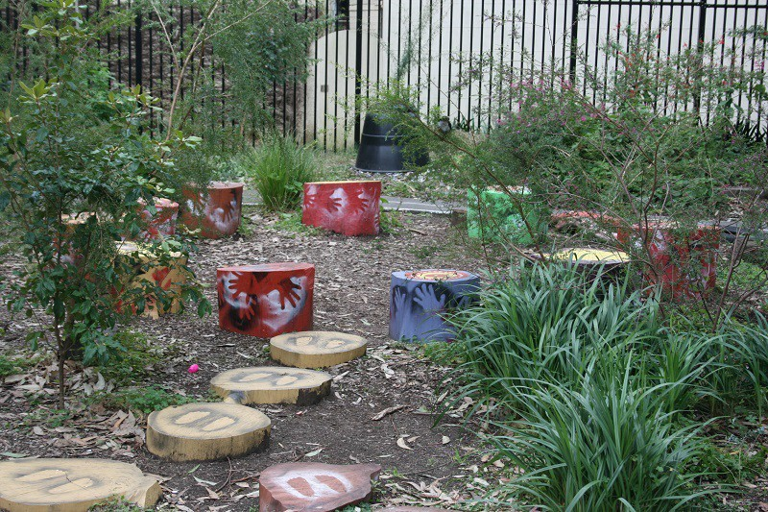

Annandale Public School

Early Intervention Preschool
  - A team approach to learning, teaching & intervention

Parent Information Book 2021
Annandale Public School Early Intervention Preschool

Annandale Public School Early Intervention Preschool provides a quality educational program for children and supports the co-ordination of services. It is an early intervention program that aims to support families in facilitating the development and care of their child. The Early Intervention Preschool achieves coordinated transition to school procedures for the children.

Staffing
Principal: Lisa Lupton
Teachers: Ms Rachel Thompson, Mrs Suess and Miss Natasha Zelesski
School Counsellor: Gail Hart and Kate Hurst

Annandale Public School Early Intervention Centre
25 Johnston Street, Annandale, 2038
School Phone: 9516 3711
Early Intervention Hours: Children attend a 2.5hr session 9-11:30am or 12:15-2:45pm for either two or three mornings/afternoons per week.
www.annandale-p.schools.nsw.edu.au

Our Philosophy
We believe early intervention should be a right, not a privilege, just like any education. The children are entitled to a balanced program that bridges the gap between their home, school and community. As stated in National Guidelines Best Practice in Early Childhood Intervention, it is our aim to assist “children of all abilities to fully participate in family and community life”.

The early childhood years are fundamentally important for all later development. For this reason, it is essential that we provide positive learning experiences for all children including those with a developmental delay or disability. They will benefit from programs based on individual needs, learn using different learning styles and at different rates and benefit from families, interdisciplinary services and staff working together.

At Annandale Early Intervention we provide a highly individualised, age appropriate curriculum that focuses on the children’s individual interests and builds on their specific strengths. We recognise best practices in early childhood intervention. At all times we strive to use “family-centred and strengths-based” practice. It is our aim to form partnerships with families that are respectful, welcoming and sensitive to diversity.

We support the children’s learning through ongoing planning; analysing, observing, evaluating and reflecting to ensure meaningful learning is taking place. Intensive individual and small group teaching occur within a highly structured, positive and nurturing environment. This reflects the Early Years Learning Framework (EYLF) cycle of planning and programming.

We respect and embrace diversity by creating an environment that celebrates culture and individuality. We aim to create a positive, respectful, inclusive and responsive relationship with families through open communication. We value inclusion as best practice. Our aim is for our students and their families to have access to developmental activities, learning and exploration.

As in all early childhood educational settings in NSW, our aim is for children’s development of independence, encouragement of social relationships, interactions and foundational skills for learning. We value collaborative teamwork. The sharing of knowledge, skills and information is valued as a way to support families and their children.

Our staff to child ratios provides for highly supported and individualized teaching with an emphasis on facilitating and encouraging the development of a lifelong love of learning. Our teachers use intervention strategies that are evidence based and reflect professional teaching standards. Our educational programs are embedded in the EYLF for Australia. The framework focuses on children’s development and their lives as characterized by Belonging, Being and Becoming.

Belonging is integral to whom children are and whom they become; recognizing that children belong to their family, culture, heritage and community.

Being is about acknowledging the present and the children learning about themselves, building and maintaining relationships with others and engaging in life’s joys and complexities being in the moment.

Becoming is about the many events that shape the lives of children. Becoming reflects these changes and focuses on the knowledge, understanding and capabilities the children learn with each new experience.

About the Program
Using the strengths of your child and your family we work in partnership with you to provide a high-quality service based on family-centred and evidence-based practice.
We believe that every family is unique, and the service should be responsive to the needs of your family. We work to build on strengths and interests of your child and family. As a family you are involved in all aspects of the service from assessment through to planning and intervention. Goals are identified with the support of the team and strategies are developed and incorporated to meet these goals.
Annandale Public School Early Intervention Unit provides research-based intervention, which encourages:
• Family centred approaches
• Collaborative service partnerships
• Inclusive service delivery
• Improved access and culturally appropriate and respectful approaches
• Strengths-based approaches

Important Events

Individual Family Service Plan (IFSP)
At the beginning of the year an initial Individual Family Service Plan (IFSP) meeting is organised. This meeting is an opportunity to jointly discuss your child’s strengths and needs and then identify specific goals that you would like your child and family to achieve.
Intervention and developing an Individual Educational Plan (IEP)
The intervention provided depends on the goals outlined in your IFSP. An individual learning plan (IEP) is then developed. The school Learning & Wellbeing Support Team will provide ongoing monitoring.
Review
Towards the end of Term two you will be invited to a review meeting at Annandale Public School to discuss school options for the following year. An application will then be submitted and a panel will be held in Term 3.
Transition to school plan
The team will assist the family and child to prepare for the transition to school. This will include school visits and attendance at meetings, providing information to the school and providing the support required by the family and the child.
Communication
We use Kinderloop as a way to communicate with families. Family members will receive a secure email invite from their child's teacher, click the 'Accept Invite' link in that email and choose a username and password that you can remember and click 'Signup'. If you have multiple children, 'Signup' with the first email and with the subsequent invites, accept the invites and 'Link' with your username and password from the first child.
General Information
Information details
Parents are required to inform the Early Intervention of changes in address, phone numbers, emergency information, health status or family situations as soon as they occur. Records and information are stored appropriately to ensure confidentiality and are maintained in accordance with legislative requirements.

Immunisation
The Department of Health asks that all children be immunised against polio, whooping cough, tetanus and diphtheria. Immunization maintains freedom from these horrific childhood diseases. A copy of your child’s immunisation history statement (via family services) will be required prior to enrolment in the Early Intervention. If your child is not immunised they must be excluded from the program should an outbreak of any of these diseases occur.

Illness
At Annandale Early Intervention steps are taken to control the spread of infectious diseases and to manage injuries and illness.

Often children may ask to come to the Early Intervention even though they are ill. Although your child may be disappointed, children must stay at home when they are sick. Should a child come to Early Intervention when he/she is not well he/she will be more vulnerable to further infection and could expose others to infection. It is in the best interest of all at Early Intervention to keep sick children at home.

Should your child have diarrhoea or vomiting in the previous 24 hours please keep him/her at home. After a fever, a child’s temperature must be normal for 24 hours before returning to Early Intervention.

If your child becomes ill while at Early Intervention and you are called, please co-operate by collecting your child promptly. We will not call unless your child needs to be at home.

Hats
For the health and safety of all children Annandale Early Intervention has adopted a “Hat On, Play On” policy. Families supply their child’s own full brim or legionnaire’s style hat to wear outside throughout the year. Families are requested to leave their child’s hat at Early Intervention for the entire year. Children are not to wear non-sun safe hats i.e. baseball caps.

Sunscreen
Our Early Intervention play areas are well shaded and outdoor times will be adjusted seasonally. Should you require your child to use sunscreen please apply this at home before leaving for Early Intervention. We recommend a 4-6 hour sunscreen to avoid the problems of re-application. As we value independence, we ask that you provide your child with a roll-on sunscreen.

Clothing
Please dress your child in comfortable play clothes which allow for self-dressing. Clothes should be easy fitting - avoid overalls or pants with belts so that your child can be independent in toileting.

It is also important that children have correctly fitted and supportive shoes for running and climbing in the outdoor area - no Crocs, thongs or slip-on shoes please!

As we are involved daily with paint, paste and water and as toileting accidents are not uncommon at this age, we ask that you provide a spare set of clothing which is to be kept in your child’s bag or locker in case it is needed. In the interests of sun safety, please ensure that your child wears clothes with sleeves (long or short) and avoid tank tops, singlets, shoestring straps, halter necks etc.

Research has shown that much of the skin damage seen in later life begins in these early years.

PLEASE MAKE SURE YOUR CHILD’S NAME IS CLEARLY MARKED ON ALL HIS/ HER CLOTHING.

School Term Dates 2021

Term 1: Monday, 1 February to Thursday, 1 April

You will be given a start time – staggered starts

Please note from week 1 staff will be arranging to meet with families, school counsellor and therapists to develop Individual Family Service Plans (IFSP).
Term 2: Tuesday 20 April to Friday 25 June
Term 3: Tuesday 13 July to Friday 17 September
Term 4: Tuesday 05 October to Thursday 16 December

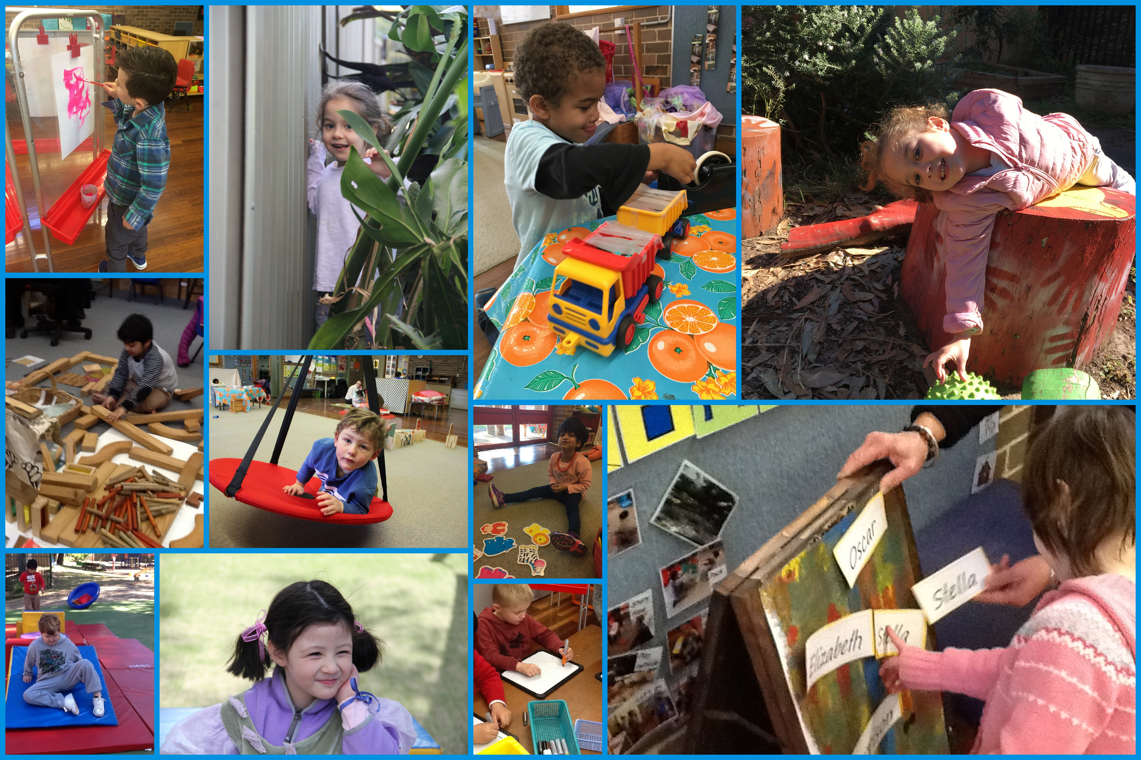
Early Intervention session (sample)
Group time | Provides opportunities for the development of literacy and numeracy skills through a combination of picture books, music/movement and cognitive activities.
Developmental  /sensory play | Provides the children with opportunities to access sensory input, acquire and practice skills such as directing play, making choices, problem solving and meeting social and language targets.
Pre-academic development | Provides children with systematic practice of fine motor and cognitive activities.
Snack time | Provides the children with opportunities to develop independence and appropriate social behaviours.
Outdoor play | Provide opportunities for social, communication, gross motor development, body awareness and hand-eye coordination. Children are supported to interact with their typically developing peers.
Group time | Provides the children with opportunities to practice target skills in a small group setting. These skills include imitating actions, singing songs, developing communication, increasing attention and recall.

