Early Intervention and Preschool Procedure
Incident, injury, trauma and illness

Current  Forbes Street Woolloomooloo 2013  T: 9358 5335/6  F: 93571831  E: plunketstr-p.school@det.nsw.edu.au | September, 2017
Next Review | 2018
Regulation(s) | R. 12, R.85-87, R. 94
National Quality Standard(s) | Standard 2.1: Health-  Each child’s health and physical activity are supported and promoted.  Standard 7.1: Governance-  Governance supports the operation of a quality service.
Relevant DoE Policy and link | Incident reporting Policy PD 2007/0362/V01  Student Health in NSW Public Schools: A summary and consolidation of policy  First aid procedures
DoE Preschool Handbook January 2016 | Wellbeing, page 32-33, 42
Key Resources | Preschool Notifications- DoE Fact sheet  ACECQA Notification of serious incident SI01  ACECQA Incident, injury, trauma and illness record

Common Procedures:
Children who become ill at preschool
- If a child becomes ill while at preschool, parents will be contacted and asked to collect them asap or arrange for their nominated emergency contact to pick them up.

- If a child has symptoms of a fever and appears unwell, their parents will be called and asked to collect them.

- The child will be made comfortable and kept under adult supervision until they recover or are collected by their parent.

- If a child is suspected of having an infectious disease, for example chicken pox, they will be isolated from other children, made comfortable and supervised by a staff member until collected.

- Families will be asked to keep any child who has been ill at home until they are fully recovered, particularly if they are contagious, have a severe cough or continually runny nose. Children who have had diarrhoea or vomiting in the previous 24hours should be kept at home. A child’s temperature must be normal for 24hours before returning to preschool.

- If a family is unsure of these procedures they will be referred to the Preschool Handbook, and if needed, referred to the Principal.

- If a child has diarrhoea at preschool their parent will be called and asked to collect them.

- If a child vomits, the educators will isolate them from the other children, monitor them and if they continue to vomit, their parent will be called and ask to collect them.

Dealing with incidents, injuries and trauma
- The nearest educator on hand will assist the child by providing basic first aid (band-aids, ice-pack) and assess the situation. If necessary, this educator will call for assistance from the nominated first aider.

- In the case of an emergency or a more serious incident or injury, the office and/or principal will be informed and depending on the severity of the situation will call an ambulance.

- Parents will be notified as soon as practical and no later than 24 hours after the occurrence. They will be requested to sign the incident record.

Recording illness and incidents, injuries and trauma
- Our educators will ensure that all incidents, injury, trauma and illness are documented on the ACECQA developed template and stored with their enrolment form. A common sense approach should be taken to decide whether the accident needs to be documented.

- The reports will be kept until the child reaches the age of 25 years, as with all children attending the school.

- Serious incidents will be reported to the principal, who in turn will contact DoE Early Learning asap, who will then notify the regulatory authority within 24hours of the incident occurring, on the SIO1form.
The definition of serious incidents that must be notified to the regulatory authority is:

- The death of a child:
- while being educated and cared for by an education and care service or
- following an incident while being educated and cared for by an education and care service.

Any incident involving serious injury or trauma to, or illness of, a child while being educated and cared for by an education and care service, which:
- a reasonable person would consider required urgent medical attention from a registered medical practitioner or
- for which the child attended, or ought reasonably to have attended, a hospital.
- e.g whooping cough, broken limb, anaphylaxis reaction

Any incident where the attendance of emergency services at the education and care service premises was sought, or ought reasonably to have been sought

- any circumstance where a child being educated and cared for by an education and care service
- appears to be missing or cannot be accounted for or
- appears to have been taken or removed from the education and care service premises in a manner that contravenes these regulations or
- is mistakenly locked in or locked out of the education and care service premises or any part of the premises.

Preschool Incident, injury, trauma and illness record
Details of person completing this record

Name: ............................................................................ Position: .......................................................................

Date and time record was made ......../......./...........................Signature: .....................................................................
Incident details

Child’s full name: ..............................................................................................................................................................
Incident date: ......../......../........ Time: ................. am/pm Location: .........................................................................
Name of witness: .................................................Witness signature: ...................................Date: ......../......../...........
General activity at the time of incident/injury/trauma/illness: ...................................................................................
........................................................................................................................................................................................
........................................................................................................................................................................................
Cause of injury/trauma: ................................................................................................................................................
........................................................................................................................................................................................
........................................................................................................................................................................................

Circumstances surrounding any illness, including apparent symptoms: .....................................................................
........................................................................................................................................................................................
........................................................................................................................................................................................
Circumstances if child appeared to be missing or otherwise unaccounted for (incl duration, who found child etc): .
..............................................................................................................................................................................………
........................................................................................................................................................................................

Circumstances if child appeared to have been taken or removed from service or was locked in/out of service (incl who took the child, duration): ......................................................................................................................................................................................
………..............................................................................................................................................................................
Abrasion/scrape Drowning (not fatal) Tooth
Allergic reaction Electric shock Venomous bite
Amputation Eye injury Venomous sting
Anaphylaxis Infectious disease Other:…………………
Asthma/respiratory High temperature
Bite wound Ingestion/inhalation/insertion
Bruise Internal injury/infection
Broken nose/fracture Poisoning
Burn/sunburn Rash
Choking Respiratory
Concussion Seizure/unconscious/convulsion
Crush/jam Sprain/swelling
Cut/open wound Stabbing/piercing

Nature of injury/trauma/illness (circle one):
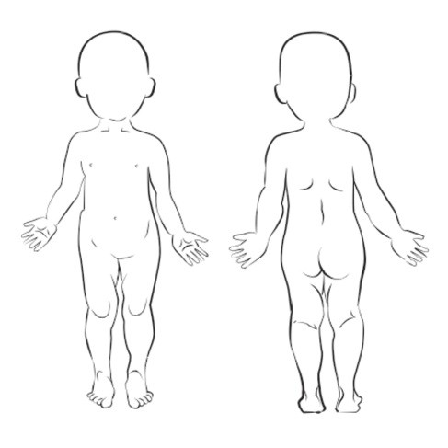
Indicate on diagram the part of body affected
Action Taken

Details of action taken (including first aid, administration of medication etc):

......................................................................................................................................................................................

......................................................................................................................................................................................

......................................................................................................................................................................................

Did emergency services attend?: Yes / No

Was medical attention sought from a registered practitioner / hospital?: Yes / No

If yes to either of the above, provide details: ..............................................................................................................

......................................................................................................................................................................................

......................................................................................................................................................................................

Have any steps been taken to prevent or minimise this type of incident in the future?:

......................................................................................................................................................................................

......................................................................................................................................................................................

.......................................................................................................................................................................................

Notifications (including attempted notifications)
Parent/guardian: ............................................................................... Time: ........... am/pm Date: ......../......../........

Teacher and/or Principal: ............................................................... ..Time: ............ am/pm Date: ......../......../........

Regulatory authority (if applicable): ................................................. Time: .............am/pm Date: ......../......../........
Parental acknowledgement:

I........................................................................................................................................ (name of parent/guardian)
have been notified of my child’s incident/injury/trauma/illness. (Please circle)

Signature: ......................................................................................................................... Date: ......../......../........
Additional notes:

...................................................................................................................................................................................

